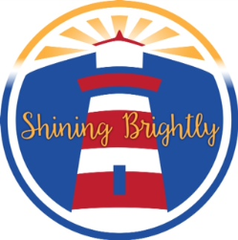



**Virtual**

**Program**

**Program Open to: Full-Remote Students Only (Group D)**

**(Other programs will be offered to Blended Students)**

**Virtual Day: Monday through Friday**

**Time: 2:00 – 5:00pm**

**TO REGISTER, CLICK ON THE LINK:**

**All applications can be completed on-line**

[**https://tinyurl.com/y6awyuvq**](https://nam10.safelinks.protection.outlook.com/?url=https%3A%2F%2Ftinyurl.com%2Fy6awyuvq&data=04%7C01%7CCValle3%40schools.nyc.gov%7C753b339605ff49d1398008d8829d1e2a%7C18492cb7ef45456185710c42e5f7ac07%7C0%7C0%7C637402958607261711%7CUnknown%7CTWFpbGZsb3d8eyJWIjoiMC4wLjAwMDAiLCJQIjoiV2luMzIiLCJBTiI6Ik1haWwiLCJXVCI6Mn0%3D%7C1000&sdata=YdAzgd%2FJaQfjOiCspfGt2NtVxYujrjWo9%2Fv3zvkyI50%3D&reserved=0)

**If you have any questions, you can contact:**

**Maria Torres @ 718-542-7676, ext. 1112**

**or**

**Carmen Valle @ 201-731-2596**

**MMCC AFTER SCHOOL PROGRAM**

**WE ARE BACK – VIRTUALLY – GRADES K THRU 5**

**BEGINS MONDAY, NOVEMBER 16, 2020**